IP network Wall Mount Speaker (2x20W)
FIP-920E
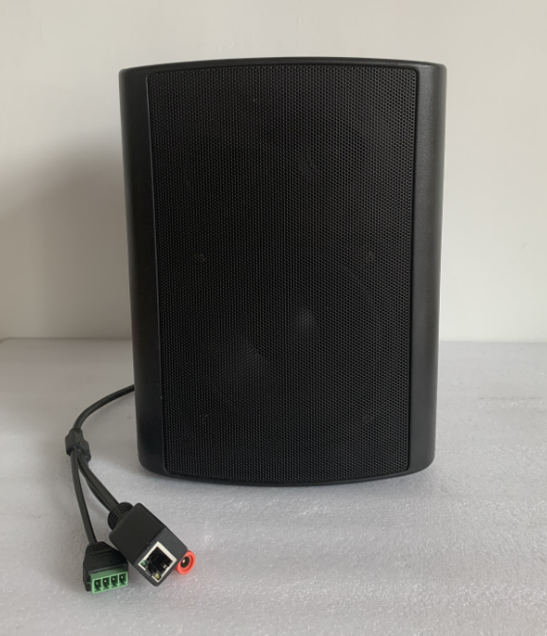
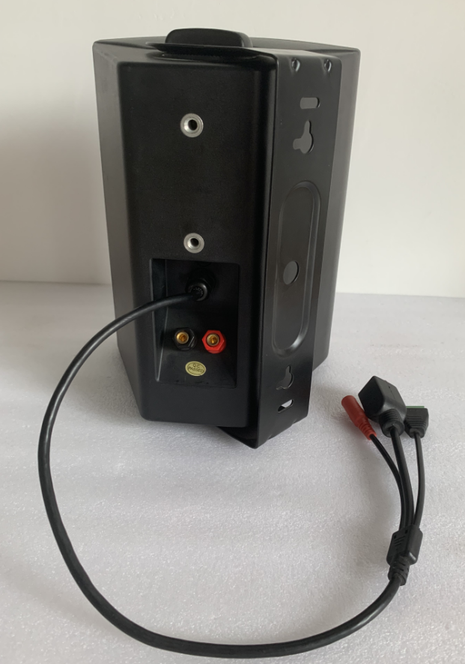

Description:

The IP network Wall Mount Speaker is with TCP/IP protocol,
enable to be built up an IP based sound system through a single CAT5 or CAT6 wire. The single CAT5 cable is used for control data, signal data and power supply, by this way, the layout cost will be much decreased compare to analog PA system.

The wall mount speaker is designed with 5” two way wall mount speaker with 2X15W class-D amplifier and stereo output, keep good sound quality by hard decoder.

The IP speaker kits is designed as an economy IP system solution, include one active speaker+ one passive speaker both in 15W RMS , with a low cost to build up the IP network speaker system

There is one contact input and one contact output to interactive with third party system. The remote paging microphone FIP-900TM enables to make announcement over individual IP speaker, group speakers over network.

Features:
- Economy IP speaker system sells in one pair
- Strong IP software with timer, BGM, paging, Support DHCP/static IP address
- IP PA system with background music, paging system and voice alarm system
- Minimum cable connection over existing LAN/WAN/Internet system
- Huge system capacity up to 1,200 zones
- Support with existing IP switch network system
- IP based POE powered 15W 5” two way wall mount speaker
- Built-in IP module, 2x15W class-D amplifier and two way speaker
- Single network cable for control, signal and power supply
- Same IP speakers enable to be several group or zone defined
- Different music or voice message simultaneously broadcasted through different IP speakers
- Paging prioritization and background music system
- IP software adjust speaker volume, Bass, Treble
- Closed contact input & Closed contact output with program
- DC12V power supply input

IP network Wall Mount Speaker (2x20W)
FIP-920E

Side View & Dimensions:
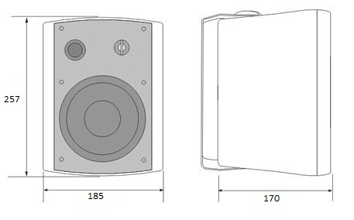

Specifications:
Model | FIP-920E
Description | IP Based Wall Mount Speaker
Power Output (1KHz@-3dB) | 20 Watts, MAX 40 Watts
Built-in Amplifier | 2X20W Watts Class D amplifier
Speaker Unit | 5” woofer+1.5” tweeter
Network I/F | 10/100Mbps
Protocol | ARP, TCP/IP, UDP, ICMP & IGMP (Group Broadcast)
Audio Format | MP3, wav
Audio Quality | 16digit stereo CD level
Sampling Rate | 8K~48K
Bit Rate | 8K~512Kbps
Sensitivity | 92dB/1W/1M
S/N Ratio | ≧85dB
THD | ≦0.1%
Frequency Response | 100-18KHz（±3dB）
Connector | One RJ45 port for existing LAN/WAN & internet  One control input, 0V, short circuit contact  One control output, 0V, short circuit contact  One DC12V input
Power Input | DC 24V
Operation Temp | -30℃ to +55℃
Dimension | 257(W)×185(D)×170(H)mm
Bracket | U-Shaped wall mount bracket
Material | ABS cabinet and steel grille
Weight | 2.5kg

